Chapter 4: Users, Groups, and Permissions

Linux is an inherently multi-user operating system built around a strict discretionary access control (DAC) model. Every running process, open network socket, configuration file, and physical peripheral is evaluated within this security perimeter. By the end of this chapter, you will understand how the Linux kernel determines identity, calculates access vectors, and manages access privileges across both individual users and administrative groups.

To prepare your environment, initialize your workspace directory:

mkdir -p ~/linux-course/lesson4
cd ~/linux-course/lesson4

4.1 Identities: Users, Groups, and the Linux Security Model
At the core of Unix security lies the concept of an identity. While humans interact with human-readable usernames like alice or sysadmin, the Linux kernel operates almost entirely on unsigned integers.

Usernames and Numeric User IDs (UIDs)
Every user account defined on a Linux host is bound to an integer known as the User Identifier (UID).

- UID 0 (root): The superuser/administrative account. UID 0 bypasses standard DAC permission checks.
- System Accounts (UIDs 1–999): Reserved by convention for system daemons, non-interactive services, and runtime users (e.g., systemd-resolve, daemon, www-data, bind). They run background services with restricted permissions.
- Standard Interactive Users (UIDs 1000+): Ubuntu and Debian assign UIDs sequentially starting at 1000 for human users created via adduser or useradd.

Groups and Group IDs (GIDs)
A Group is a logical container used to assign identical access rights to a collection of users simultaneously. Like users, groups are identified internally via a Group Identifier (GID). Group classifications include:

- Primary Group: Specified in /etc/passwd. When a user creates a new file or directory, the object is automatically assigned to the user's primary group by default.
- Supplementary (Secondary) Groups: Specified in /etc/group. These provide secondary access paths, allowing users to inherit permissions from multiple project groups, administrative tiers (e.g., sudo), or hardware device access pools (e.g., plugdev, docker).

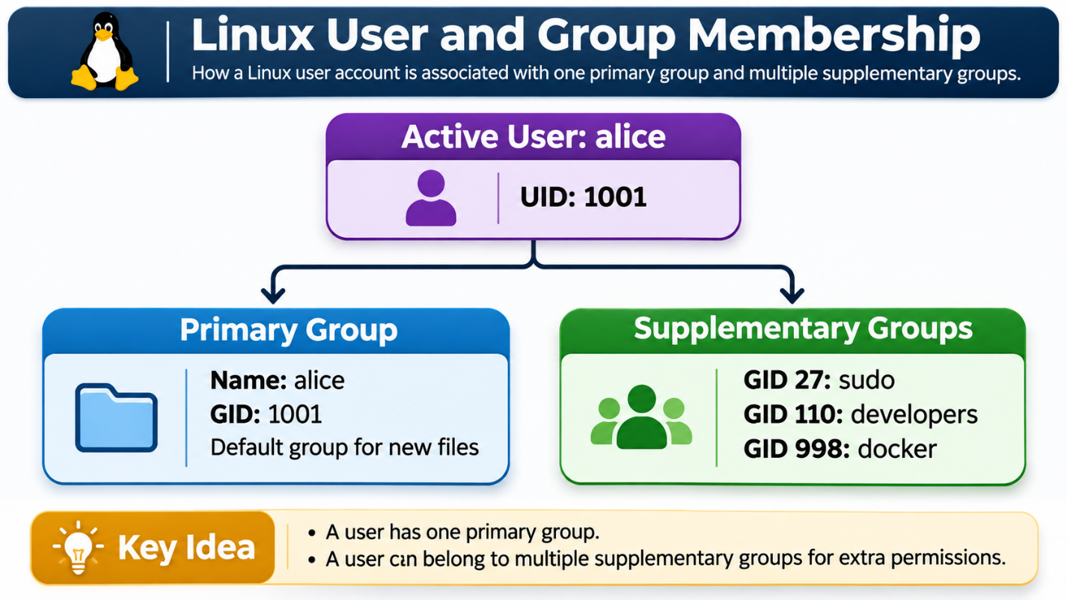

Kernel Identity Evaluation
When a user launches a process (such as a Bash shell, compiler, or text editor), that process inherits the security context of the user executing it. The process is tagged with:

- Real UID (RUID) / Real GID (RGID)
- Effective UID (EUID) / Effective GID (EGID)
- Supplementary Group List

When this process requests access to a file system object (to open, read, write, or execute), the Linux kernel compares the process's effective identity attributes against the object’s stored metadata. The kernel verifies access sequentially:

- Does the process UID match the object Owner UID?
- If not, does the process GID (or any of its supplementary GIDs) match the object GID?
- If neither matches, evaluate against the "Other" (world) permission bits.

Identity Inspection: id and groups
You can inspect the security context of the current session or a targeted user account via two utilities:
$ id
uid=1000(ubuntu) gid=1000(ubuntu) groups=1000(ubuntu),4(adm),24(cdrom),27(sudo),30(dip),46(plugdev),110(lxd)
$ id alice
uid=1001(alice) gid=1001(alice) groups=1001(alice),27(sudo),1002(devops)
$ groups
ubuntu adm cdrom sudo dip plugdev lxd

The Identity Databases: /etc/passwd and /etc/group

/etc/passwd
This world-readable plain-text file defines local user accounts. Each record follows a strict colon-delimited format:
alice:x:1001:1001:Alice Chen,Room 402:/home/alice:/bin/bash
[1] [2] [3] [4] [5] [6] [7]
- Username: Login handle (alphanumeric string).
- Password Placeholder: The character x indicates that the hashed password is stored in the restricted file /etc/shadow.
- UID: Numeric user ID.
- Primary GID: Numeric group ID representing the user's primary group.
- GECOS Field: General system information (full name, office, phone numbers).
- Home Directory: Absolute path to the user's personal file tree.
- Default Shell: Binary invoked when the user starts an interactive session.

/etc/group
This file defines system groups and supplementary group memberships:t
devops:x:1002:alice,bob,carol
[1] [2] [3] [4]
- Group Name: Identifier string.
- Group Password Placeholder: Indicates password hashes (rarely used) are deferred to `/etc/gshadow`.
- GID: Numeric group ID.
- Member List: Comma-separated list of usernames belonging to this group in a supplementary capacity. (Note: A user's primary group membership is not listed here; it is defined in `/etc/passwd`).

4.2 Reading Ownership and Permission Bits

When listing files with `ls -l`, each entry displays its core DAC metadata:
$ ls -l /var/log/syslog
-rw-r----- 1 syslog adm 214042 Oct 24 10:14 /var/log/syslog

Let's dissect this 10-character string and its associated ownership metadata:
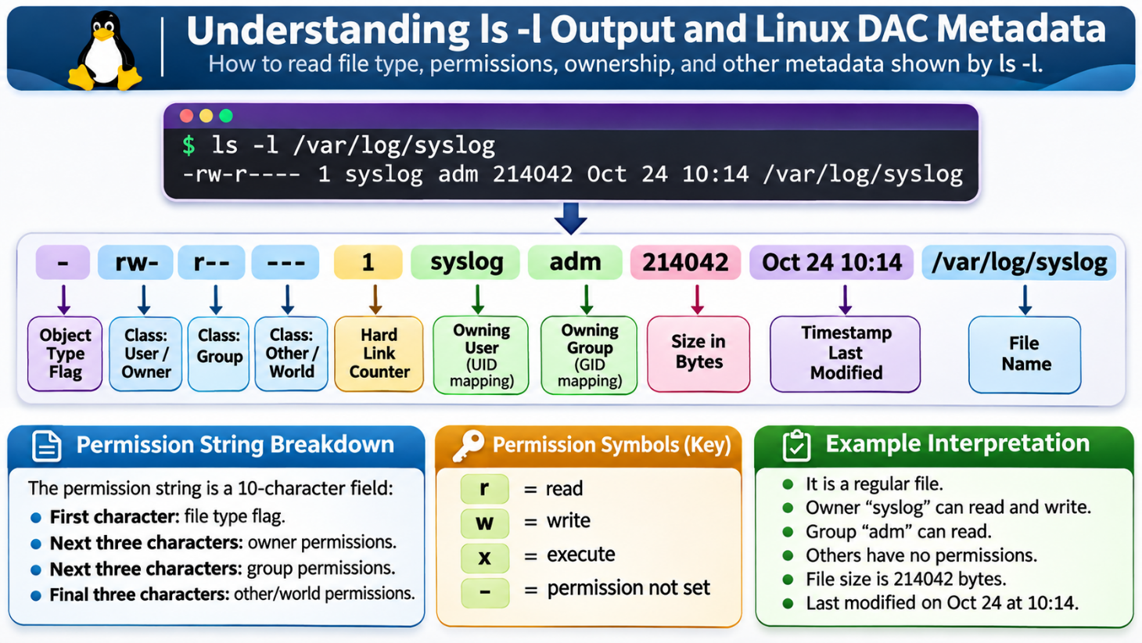

The Object Type Flag (Character 1)
The first character determines the inode's functional classification:

- -: Standard regular file (text, executable binary, compressed archive, image).
- d: Directory (a list of directory entries mapping names to inodes).
- l: Symbolic link (points to another path in the VFS).
- c: Character device file (unbuffered, serial access, e.g., /dev/tty, /dev/null).
- b: Block device file (buffered, block-oriented I/O, e.g., /dev/sda, /dev/nvme0n1).
- s: Local UNIX domain socket (inter-process communication endpoint).
- p: Named pipe / FIFO (first-in, first-out inter-process communication stream).

The 9-Bit Permission Triplet
Characters 2 through 10 represent three distinct sets of permissions, each containing three functional bits: Read (r), Write (w), and Execute (x).

- User (Owner) [u]: Permissions applied exclusively to the specific UID matching the file's owner.
- Group [g]: Permissions applied to any user who is a member of the GID matching the file's group, provided they are not the file owner.
- Other (World) [o]: Permissions applied to any user process whose UID does not match the file owner and whose active GIDs do not match the file group.

Evaluation Order: First-Match Semantics
A common point of confusion is how the kernel resolves permissions. The Linux kernel uses a first-match rule, not a cumulative rule:

[Is process UID == File UID?]
|
YES ---> Kernel applies "Owner" permissions. EVALUATION STOPS.
|
NO
|
[Is process GID (or supplementary GID) == File GID?]
|
YES ---> Kernel applies "Group" permissions. EVALUATION STOPS.
|
NO
|
v
Kernel applies "Other" permissions. EVALUATION STOPS.

Security Warning: If a file has permissions - --- rw- r--, and user alice owns that file, alice will receive --- (no access). Even though the group and world have read permissions, evaluation stops at the matching Owner class.

4.3 Permissions by Object Type: Regular Files vs. Directories
The permission bits r, w, and x have very different meanings depending on whether they are placed on a regular file or a directory.

Permission Bit | Context: Regular File | Context: Directory
Read (r) | Inspect and read file contents (cat, less, open for reading). | List directory contents (ls). Inodes and names can be read.
Write (w) | Modify, append, or truncate file contents (echo >, editors). | Create, delete, or rename directory entries within the folder.
Execute (x) | Run the file as an application binary or interpreted script. | Traverse / Search through the directory; access its contents or chdir into it.

The Critical Role of Directory Execute (x)
On a regular file, the execute bit marks a file as runnable by the shell or the execve() system call.

On a directory, execute (x) means traversal. Without the execute bit on a directory:

- You cannot cd into the directory.
- You cannot access any file or subfolder located within it, even if you know the exact filename.
- You cannot inspect inode metadata for its entries (such as size or modification dates), even if the directory itself has read permissions (r).

Let's test this behavior:h
mkdir test_dir
touch test_dir/target.txt
chmod 0644 test_dir # Read permissions enabled, Execute disabled
ls -l test_dir

Output:
```text
ls: cannot access 'test_dir/target.txt': Permission denied
target.txt

Notice that while ls could read the filename target.txt because of the r bit, it could not determine any attributes (permissions, owner, size) because traversing to the file's inode requires directory execute (x) permissions.

Deleting Files: A Directory Operation
A common point of confusion for new system administrators:Fundamental Rule: The ability to create, delete, or rename a file is controlled by the write (w) and execute (x) permissions of the parent directory, not the permissions on the file itself!

If a user has wx access to /shared/project/, that user can delete /shared/project/database.sqlite, even if database.sqlite is owned by root and has read-only permissions (-r--------). Deleting a file unlinks an entry from the parent directory's table, which modifies the directory, not the target file's inode contents.

4.4 Modifying Permissions with chmod
The chmod (change mode) command modifies file and directory mode bits. Permissions can be set using either Symbolic Notation or Octal (Numeric) Notation.

Symbolic Notation
Symbolic notation uses character codes to target classes, apply operators, and set permissions.

chmod [references] [operator] [modes] file
(u,g,o,a) (+,-,=) (r,w,x)

- References (Classes):
  - u: User (Owner)
  - g: Group
  - o: Others
  - a: All classes (ugo)
- Operators:
  - +: Add the specified permissions without altering existing bits.
  - -: Strip the specified permissions.
  - =: Explicitly define permissions, overwriting all other bits for that class.
- Modes:
  - r: Read
  - w: Write
  - x: Execute

Symbolic Examples:
chmod u+x script.sh # Add execute to the file owner
chmod g-w,o-r report.pdf # Strip write from group, strip read from others
chmod a=r public.txt # Set read-only for owner, group, and others
chmod ug+rw database.db # Add read and write to both owner and group
chmod o= secrets.env # Strip all permissions from others (empty right-hand side)

Octal (Numeric) Notation
Octal notation maps the three permission bits of each class to a 3-bit binary value, which is then represented as a base-8 digit (0–7).
r w x
4 + 2 + 1 = 7

Binary Value | Octal Digit | Expanded Representation | Functional Description
000 | 0 | --- | No permissions granted
001 | 1 | --x | Execute only (traversal for directories)
010 | 2 | -w- | Write only
011 | 3 | -wx | Write and Execute
100 | 4 | r-- | Read only
101 | 5 | r-x | Read and Execute
110 | 6 | rw- | Read and Write
111 | 7 | rwx | Read, Write, and Execute

To construct a 3-digit octal permission string, combine the sums for User, Group, and Other:
User (Owner) Group Other
r w x r - x r - -
(4 + 2 + 1) (4 + 0 + 1) (4 + 0 + 0)
7 5 4 ===> Mode 754

Common Standard Modes

Mode | Symbolic Equivalence | Intended Application
755 | -rwxr-xr-x | System binaries, custom shell scripts, accessible directories
644 | -rw-r--r-- | Standard configuration files, static documents, source code
640 | -rw-r----- | Secure service logs, configuration files containing internal secrets
750 | drwxr-x--- | Team directories accessible only to the owner and designated group
600 | -rw------- | Sensitive credentials, private SSH keys (~/.ssh/id_rsa), API secrets
700 | drwx------ | User home directories, root's home directory (/root), personal data

Operational Warnings
DANGER: chmod 777
Never run chmod 777 to resolve permission problems. Mode 777 (rwxrwxrwx) grants full read, write, and execute permissions to every user on the system, creating significant security vulnerabilities:

- Any untrusted local account or compromised service can overwrite or delete the data.
- It exposes paths to injection attacks and script tampering.
- Modern utilities (such as ssh and gpg) will actively refuse to function if sensitive files or directories use mode 777.

CAUTION: Recursive chmod (chmod -R)
Using chmod -R 755 /path or chmod -R 644 /path recursively across a mixed directory tree will break permissions:

- Applying 644 recursively removes the execute bit from directories, making them un-traversable.
- Applying 755 recursively makes non-executable data files executable.

Instead, target files and directories separately using find:

# Apply 755 only to directories
find /target/dir -type d -exec chmod 755 {} +

# Apply 644 only to regular files
find /target/dir -type f -exec chmod 644 {} +

4.5 Default Permissions and the umask
When a process creates a new file or directory, it cannot assign arbitrary permissions. Instead, it submits an initial mode request:

- Initial file creation request: 0666 (rw-rw-rw-) — Files are not created with execute permissions by default.
- Initial directory creation request: 0777 (rwxrwxrwx) — Directories require execute permissions for navigation.

These requested permissions are then filtered through the process's umask (user mask).

Requested Initial Mode 0666 (rw-rw-rw-)
- Bitwise Mask (umask) 0022 (----w--w-)
----------------------------------------------------
= Resultant Permission Mode 0644 (rw-r--r--)

The umask strips permissions from the initial request. Any bit set to 1 in the umask is removed from the newly created object.

Calculating Resulting Permissions
File Mode Formula: (0666 & ~umask)
Directory Mode Formula: (0777 & ~umask)

For basic calculations, you can subtract the umask from the base mode (as long as no carry operations are involved):

Mask Setting | File Calculation (Base 666) | Directory Calculation (Base 777) | Security Profile
0022 | 666 - 022 = 644 (rw-r--r--) | 777 - 022 = 755 (rwxr-xr-x) | Standard multi-user system default
0027 | 666 - 027 = 640 (rw-r-----) | 777 - 027 = 750 (rwxr-x---) | Hardened internal environment (isolated from world)
0077 | 666 - 077 = 600 (rw-------) | 777 - 077 = 700 (rwx------) | Strict isolation (private to owner only)

Inspecting and Altering the Umask
To display the current shell's mask:
$ umask
0022
$ umask -S
u=rwx,g=rx,o=rx

To modify the mask for the current shell session:
$ umask 027
$ touch secure_file.txt
$ mkdir secure_folder
$ ls -ld secure_file.txt secure_folder
-rw-r----- 1 ubuntu ubuntu 0 Oct 24 10:45 secure_file.txt
drwxr-x--- 2 ubuntu ubuntu 4096 Oct 24 10:45 secure_folder

Important Operational Rule: Changing the umask only affects files and directories created after the change within the active shell and its child processes. The umask never modifies existing filesystem objects retroactively.

4.6 Ownership Management: chown and chgrp
Modifying the user or group ownership of a filesystem node is done with the chown and chgrp utilities.

Administrative Privilege Requirements
In Linux, standard users cannot give away ownership of their files. Even if you own a file, you cannot chown it to another user:

$ touch my_notes.txt
$ chown alice my_notes.txt
chown: changing ownership of 'my_notes.txt': Operation not permitted

This restriction prevents several security issues:

- Users cannot consume another user's storage quota by transferring large files.
- Users cannot hide malicious scripts or sensitive files by reassigning ownership to someone else.

As a result, changing file ownership requires superuser privileges (sudo).

The chown Command
The chown command modifies user ownership, group ownership, or both:

sudo chown [OPTIONS] USER[:GROUP] FILE...

Common Syntax Variants:
# 1. Change only the user owner
sudo chown alice data.csv

# 2. Change both the user owner and the group owner
sudo chown alice:developers data.csv

# 3. Change only the group owner (notice the leading colon)
sudo chown :developers data.csv

# 4. Change user owner and set the group to that user's primary group
sudo chown alice: data.csv

# 5. Recursively alter an entire directory hierarchy
sudo chown -R www-data:www-data /var/www/html/

The chgrp Command
The chgrp command is a dedicated utility for changing group ownership. Standard non-root users can use chgrp, but only to switch ownership to a group they currently belong to:

# If user 'ubuntu' is a member of 'developers':
chgrp developers project_plan.odt

4.7 Special Permission Bits and Access Control Lists (ACLs)
Standard DAC permissions (rwx) are sufficient for basic workflows, but advanced administration requires additional access controls.

Special Permission Bits: SUID, SGID, and the Sticky Bit
Three additional permission bits modify how executables run and how directories manage files.

[Special Bits] [User] [Group] [Other]
4/2/1 7 5 5

Special Bit | Octal Value | Target Object | Symbolic Representation | Functional Effect
SUID (Set User ID) | 4000 | Executable File | rwsr-xr-x (replaces user x) | Process runs with the privileges of the file owner, rather than the user invoking it.
SGID (Set Group ID) | 2000 | Executable File | rwxr-sr-x (replaces group x) | Process runs with the privileges of the file group.
SGID (Set Group ID) | 2000 | Directory | drwxrwsr-x (replaces group x) | New files created inside inherit the group ownership of the parent directory.
Sticky Bit | 1000 | Directory | drwxrwxrwt (replaces other x) | Users can only delete or rename files they own, even if the directory is world-writable.

1. SUID in Practice
The classic example of SUID is the /usr/bin/passwd utility. Standard users must be able to change their passwords, which requires updating the privileged /etc/shadow file. The SUID bit allows regular users to run /usr/bin/passwd with temporary root permissions:

$ ls -l /usr/bin/passwd
-rwsr-xr-x 1 root root 68208 Nov 29 14:15 /usr/bin/passwd

Note: If the underlying execute bit is missing, the symbolic representation displays a capital S (-rwSr-xr-x), indicating a misconfiguration.

2. SGID on Shared Directories
When collaborating within a shared group directory, new files are usually created with the author's primary group. Setting the SGID bit on the directory ensures that all new files inherit the directory's group instead:

sudo chmod 2775 /opt/collaborative_project/
# Or symbolically:
sudo chmod g+s /opt/collaborative_project/

3. The Sticky Bit on Shared Directories
The /tmp directory is globally accessible and writable by all users (mode 1777). The sticky bit ensures that users cannot delete or rename each other's files:h
$ ls -ld /tmp
drwxrwxrwt 22 root root 4096 Oct 24 11:00 /tmp

Note: If the execute bit is not set for others, the sticky bit is displayed as a capital `T`.

Introduction to POSIX Access Control Lists (ACLs)
Standard Linux permissions allow only one owning user and one owning group per file. Access Control Lists (ACLs) provide finer-grained permissions, allowing you to grant access to multiple specific users or groups.

Two primary utilities manage ACLs:
- `getfacl`: View extended permissions.
- `setfacl`: Configure extended permissions.

View active permissions and ACLs
getfacl document.pdf
Output:
file: document.pdf
owner: alice
group: devops
user::rw-
group::r--
other::---

Modifying ACLs with `setfacl`
To grant user `bob` read-write access to a file he does not own:
setfacl -m u:bob:rw document.pdf

Notice the trailing + symbol in the standard ls -l listing, which indicates that an active ACL is present:
$ ls -l document.pdf
-rw-rw----+ 1 alice devops 15420 Oct 24 11:15 document.pdf

Revisiting getfacl:

$ getfacl document.pdf
# file: document.pdf
# owner: alice
# group: devops
user::rw-
user:bob:rw-
group::r--
mask::rw-
other::---

The ACL Mask
The mask:: entry defines the maximum effective permissions for all named users, named groups, and the owning group. If the mask is modified to r--, any rw- rules for those users will be capped at read-only.

To strip all extended ACLs and restore standard DAC behavior:
setfacl -b document.pdf

4.8 The Principle of Least Privilege and Safe Permission Workflows
Security administration relies on the Principle of Least Privilege (PoLP):Principle of Least Privilege: A user, process, or system component must be granted only the minimum access levels necessary to complete its legitimate operational tasks, and for no longer than required.

Applying this principle requires avoiding shortcuts like broad permissions (chmod 777) or running everyday tasks as root.
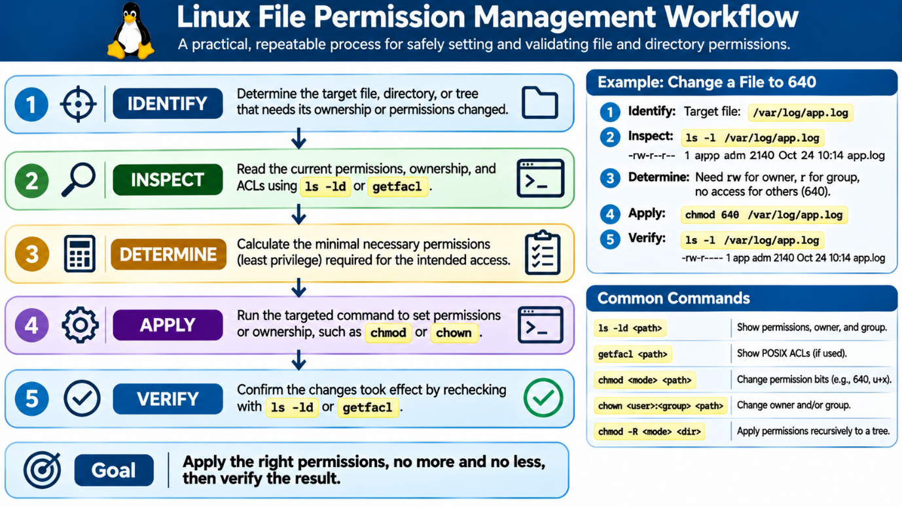

The 5-Step Safe Permission Routine
Follow this 5-step workflow whenever updating permissions:

- Identify the Scope: Identify the exact target file or directory. Avoid using loose wildcards (e.g., chmod 755 *).
- Inspect Current State: Run ls -l or ls -ld <directory> to verify current ownership and permissions.
- Determine Minimum Access: Calculate the most restrictive mode that still allows the required task to succeed.
- Apply Targeted Change: Use explicit symbolic or octal arguments. When changing subtrees, use find instead of broad -R flags.
- Verify the Result: Confirm the new permissions with ls -ld or getfacl, and verify that the target user can run the intended command without access errors.

4.9 Hands-On Student Lab
Work through the following exercises in your terminal to practice the concepts covered in this chapter.

cd ~/linux-course/lesson4

Part A: Identity Inspection
- Run the id command with no arguments. Write down your current UID, primary GID, and supplementary groups.
- View your user record in /etc/passwd using grep:
grep "^$USER:" /etc/passwd

- Locate all system groups your user account belongs to in /etc/group:
grep "$USER" /etc/group

Part B: Creating the Test Sandbox
Create the practice directory structure and files:

mkdir -p sandbox/scripts sandbox/conf sandbox/public
touch sandbox/scripts/deploy.sh
touch sandbox/conf/app.env
touch sandbox/public/index.html

Part C: Symbolic chmod Practice
- Add execute permissions for the owner to deploy.sh:
chmod u+x sandbox/scripts/deploy.sh

- Remove all permissions for other users from app.env:
chmod o-rwx sandbox/conf/app.env

- Ensure index.html is readable by all users, but writable only by the owner:
chmod u=rw,go=r sandbox/public/index.html

- Verify your changes using ls -l across all three paths:
ls -l sandbox/*/*

Part D: Octal chmod Practice
- Set the permissions on sandbox/scripts/deploy.sh to mode 750:
- chmod 750 sandbox/scripts/deploy.sh

- Set sandbox/conf/app.env to mode 600:
chmod 600 sandbox/conf/app.env

- Change the sandbox/conf directory to mode 700:
chmod 700 sandbox/conf

- Check your work:
ls -ld sandbox/conf
ls -l sandbox/conf/app.env

Part E: Investigating the umask
- Check your shell's current umask:
umask

- In your lesson directory, set a strict umask:
umask 077

- Create a test file and directory:
touch umask_test.txt
mkdir umask_dir

- Check the permissions with ls -ld:
ls -ld umask_test.txt umask_dir
Did the file get created with 600 and the directory with 700?

- Reset your umask to standard mode:
umask 022

Part F: Directory Traversal and Sticky Bits
- Create a public-style directory:
mkdir shared_drop
chmod 777 shared_drop

- Add the sticky bit:
chmod +t shared_drop

- Verify the final mode:
ls -ld shared_drop
Expected output: drwxrwxrwt.

4.10 Chapter Key Terms Glossary
- User Identifier (UID): A unique integer used by the Linux kernel to identify a specific user account.
- Group Identifier (GID): A unique integer used by the Linux kernel to identify a specific group.
- Discretionary Access Control (DAC): A security model where access permissions are set by the object's owner based on user and group identities.
- Owner (User / u): The specific user account that owns a given file or directory.
- Group (g): The group associated with a file, granting permissions to all users who belong to that group.
- Others (o): Any user account that is neither the file owner nor a member of the file's group.
- Read (r): The permission bit that allows reading file contents or listing directory contents.
- Write (w): The permission bit that allows modifying file contents, or adding/removing files within a directory.
- Execute (x): The permission bit that allows running a file as a program, or traversing into a directory.
- chmod: The utility used to view and change file system mode flags and permission bits.
- chown: The utility used to change the user and group ownership of files and directories.
- umask: A configuration value that filters out specified permissions when new files or directories are created.
- SUID (Set User ID): A special permission bit that runs an executable with the permissions of the file owner.
- SGID (Set Group ID): A special permission bit that runs an executable with the file group's permissions, or causes new files in a directory to inherit its group.
- Sticky Bit: A special permission bit on shared directories that prevents users from deleting or renaming files owned by others.

4.11 Review Questions

Concept Review Questions
- How does the Linux kernel determine identity when evaluating file access requests from a running process?
- What are the three standard user classes evaluated in the Linux DAC permission model?
- How does the kernel interpret the execute bit (x) differently for regular files compared to directories?
- If a file has permissions 000 (---------), but the parent directory has mode 777, can an unprivileged user delete that file? Why or why not?
- What are the octal values for the Read, Write, and Execute bits?
- Calculate the 3-digit octal value for: User has read/write, Group has read, Other has no access.
- Why is chmod 777 considered a dangerous practice in production environments?
- If your current umask is 027, what permissions will a newly created regular file receive? What about a newly created directory?
- Why does chown require administrative privileges (sudo), while regular users can change permissions on files they own with chmod?
- What operational problem does setting the SGID bit on a shared project directory solve?
- How does the sticky bit protect shared directories like /tmp?
- What is the difference between standard POSIX permissions and POSIX Access Control Lists (ACLs)?

Lab Reflection Questions
- In Part C, what happened when you set chmod o-rwx on sandbox/conf/app.env? Which users lost access to that file?
- In Part D, why is it standard practice to set configuration directories to mode 700 or 750 when they contain sensitive environment variables?
- In Part E, what base value was used to calculate the permissions for umask_test.txt when the umask was set to 077?
- When you ran ls -ld shared_drop in Part F, why did the last character change to t?
- How would you revert all files in ~/linux-course/lesson4/sandbox back to the default 644 (files) and 755 (directories) permissions using a single safe workflow?

